**Vaccination Output**

**User Registration :**

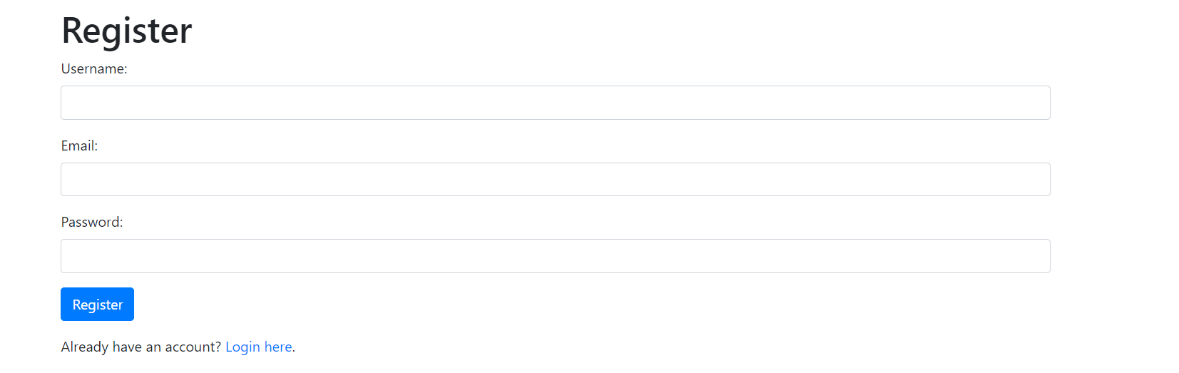

**If already registered ,then login :**

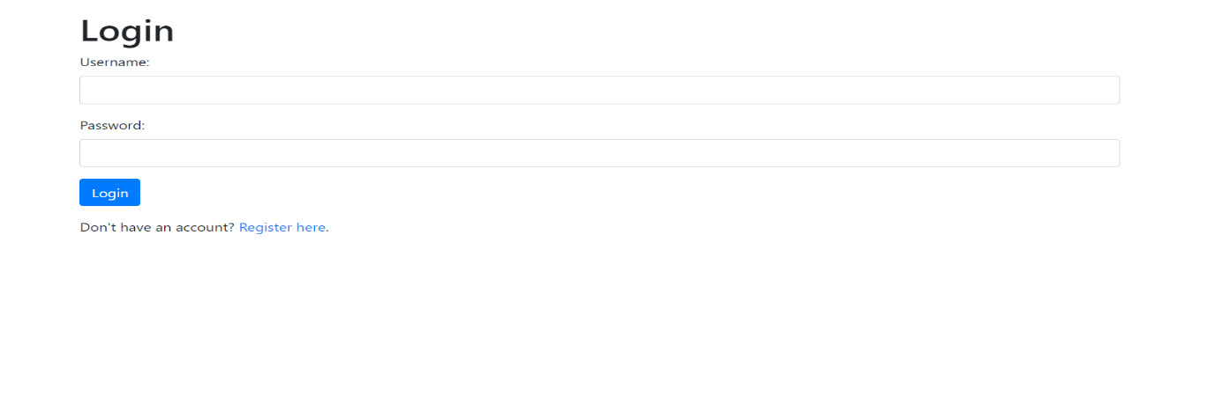

**If credentials are wrong ,then error page :**

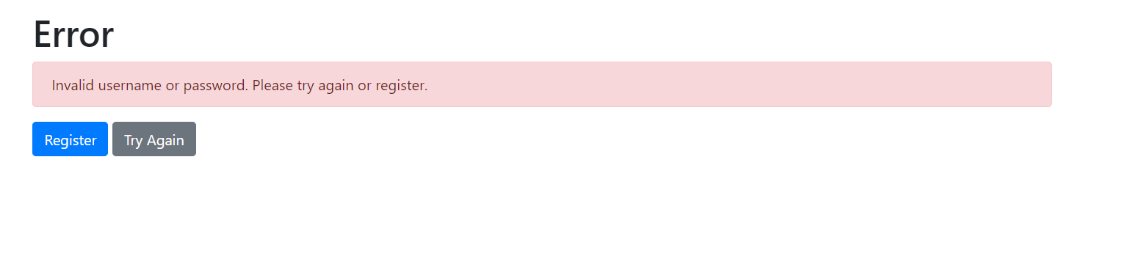

**Adding vaccination center:**

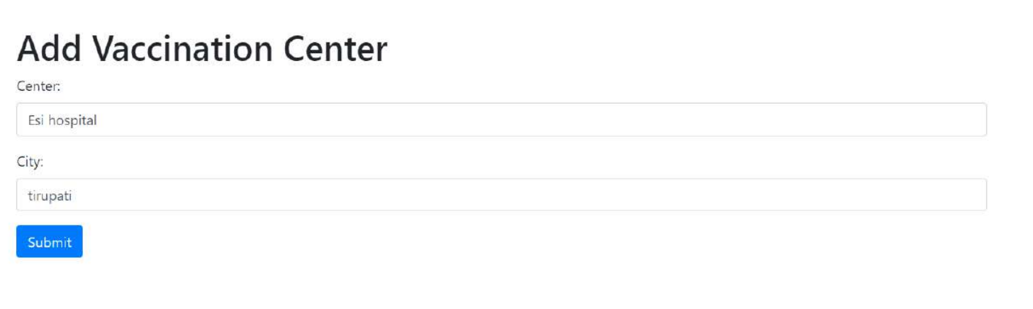

**Vaccination Portal welcome:**

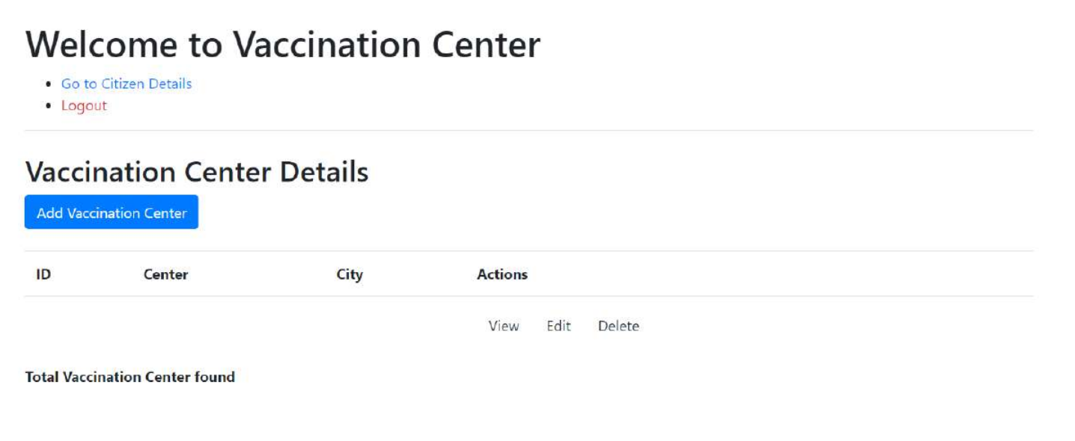

**Add Citizen:**

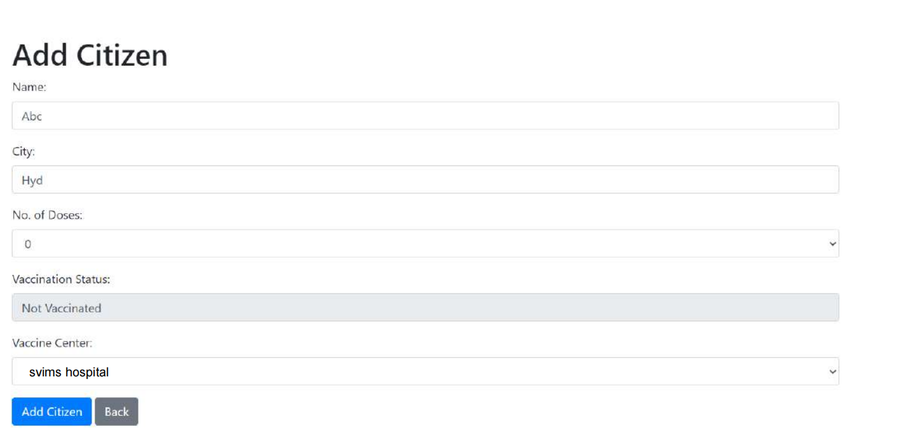

**Citizen details portal :**

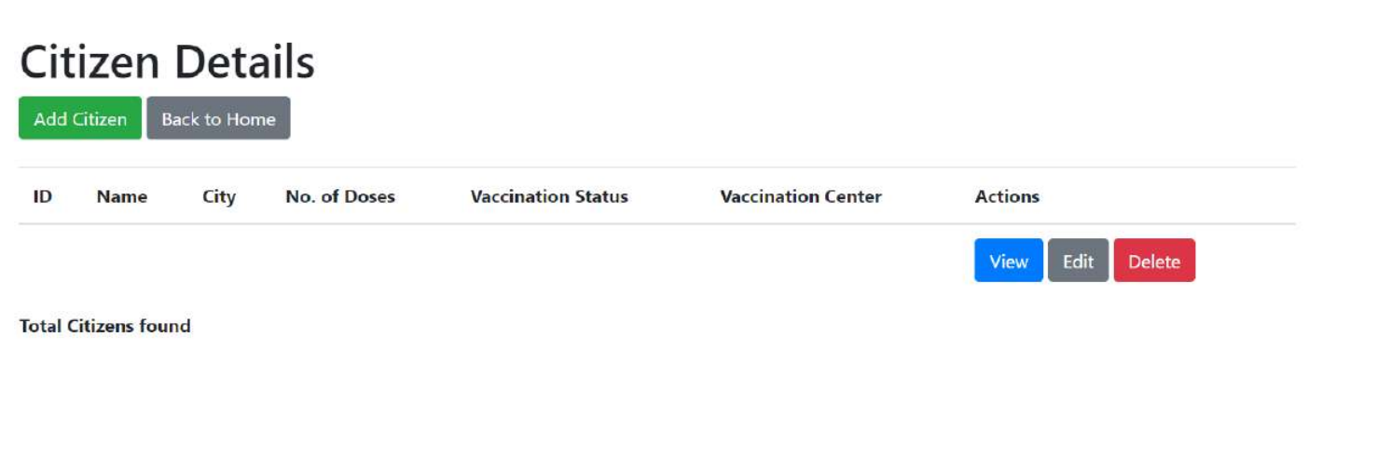

**Editing and updating citizzen’s details :**

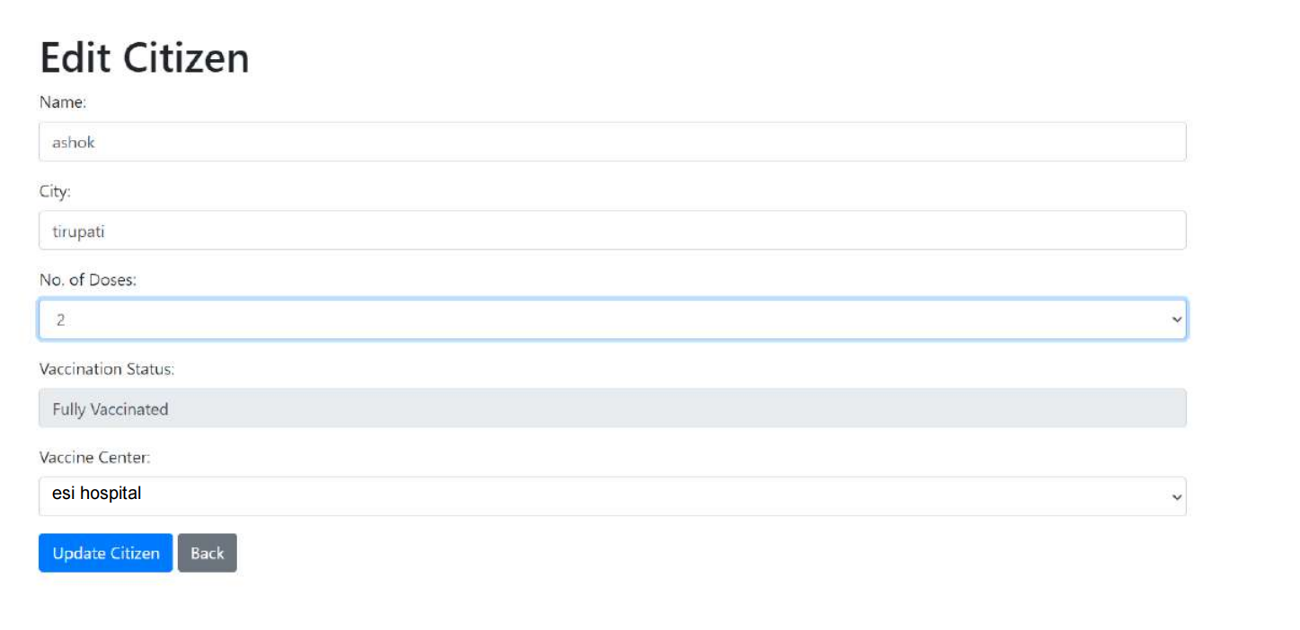

**Vaccination Center details Edit :**

